1.The HF welding process
This section describes the HF welding process in simple terms. The fusing of the material in the area of the weld is explained, followed by the method used to practically perform the weld.
2.1. Why use high frequency power?
Plastic material can be welded by applying heat externally, e.g. by using a tool similar to a domestic iron or a hot air gun. Generally, this form of welding is restricted to very thin material, such as polyolefins.
Bulky items such as some tarpaulins which are too large to be accommodated in an HF welding machine, are sometimes welded by using a hot air gun. This type of welding is difficult and can be used successfully carried out by experienced operators.
Other types of plastic materials can be welded by direct heat alone, but the process is impractical. If direct heat alone is applied to PVC it can degrade the outer surface, which may overheat before thw inner surfaces are hot enough to weld together.
The High Frequency welding technique overcomes the problems associated with the application of the direct heat alone, and enables plastic material to be welded under controlled conditions.
By applying a controlled of HF power, it is possible to heat the materials so that the zone of resulting higher temperatures includes the surfaces to be welded together. Heating the contact boundaries using this method forms a strong weld without damaging the outer surfaces of the material.
HF welding depends on a process of converting electrical energy into heat energy within the work pieces to raise their temperatures enough to melt and therefore fuse them.
Materials that do not conduct electricity such as air, oil and PVC are sometimes called dielectrics. In HF welding the plastic dielectric materials to be welded and sandwiched between two conductors, called electrodes. When HF power is passed between these electrodes; an alternating electric field is generated through the dielectric materials. The switching electric fields agitate the dielectric material’s molecules causing it to heat up. The effects of heating is at maximum at a point half way between the electrodes, at the junction of two dielectric materials due to the heat-sonk effect of the colder electrodes in contact with the surfaces.
Once the dielectric material have fused, the HF power is switched off and the workpieces are allows to cool.
The frequency used by most HF welding machines is 27.12MHz, this means the electric field is cycled 27.12million time per second. As each cycle comprises is positive half cycle and a negative half cycle, the electric field is applied at twice the frequency, i.e. 54.24 million times per second.
2.2. Practical HF welding
In HF welding, the lower electrode is usually a wide flat metal plate generally called a platen. A large welding machine may also be provided with a moving upper platen which carries tooling shape to create the required weld pattern in the work pieces.
The upper platen is connected to the HF supply and moves up and down during the welding process enabling the tooling to be brought into the contact with workpieces. The force with which the upper platen presses against the workpieces. Can be applied by springs, weights or for “heavy” welding by electric motor, compressed air or hydraulics.
2.3. Barrier material
A barrier, or buffer, is a thin of sheet of dielectric that is placed between the work material and the welding machine’s lower platen. This can help the welding process in several ways, depending on the properties of the barrier materials. Any material used as a barrier must be able to be repeatedly used in the electric field without being affected.
Barrier material has two distinct purposes. Firstly, it prevents the cutting edge of a tear-seal electrode touching the bottom platen and thereby causing an arc, and secondly, it provides a thermal barrier to prevent the bottom platen absorbing heat from the workpieces.
A barrier sheet will usually be between 0.15mm and 0.5mm in thickness, this is enough to decrease to heat flow, and increase the weld temperature thus allowing a larger area of weld to be made with a given amount of HF power. Too much thermal thermal insulation will cause the workpieces to melt near to its outer surface, rather than at the interface of the two pieces.
The dielectric strength of barrier material is measured in kW/mm. This measurement gives an indication of the voltage which can be applied across the material before it breaks down and loses its insulation properties.
The most popular buffer materials are composite materials, e.g. waxed paper or varnished cotton. These flexible materials can be easily stored and cut.
Some examples of commonly used barrier materials are:
Elefantide – Supplied in various thicknesses and in roles 1219mm wide. Also, available in with thin film Melinex laminated to its surface which gives a good shine on reverse side of the welded line and the PVC has a tendency to stick lightly alone and weld lines.
Silicone rubber – Flexible rubber sheathing, available in rolls of several thicknesses. Works up to 160ºC, non-stick, not affected by the HF used by welding machines. It is ofen used in car door panel production
Paxolin- Rigid sheeting of thermosetting resin impregnated paper, available in squares of different thicknesses and areas. Usually, the lighter the colour of material, the better the quality. It disadvantage is that it may split or crack when cut.
Melinex- This is a tough material that will resist the wear and tear from the cutting edges of the welding tools. It can also be used in combination with another material that provides additional electrical and thermal insultation

2.4. Setting machine controls
The welding process is generally quite tolerant of machine settings, and satisfactory welds can be obtained even if one or more of settings is not at its optimum value. The tolerance of the settings is dependent on on the material being welding, PVC is relatively tolerant but other material, for example medical film are not. However, with optimum settings a satisfactory weld will be over a wide range of conditions which may occur in a typical operating period. For example, the temperature of the upper platen will increase as work progresses and workpiece material may vary in quality, even if from the same batch.
Settings for a specific job cannot be repeated at a later date. The composition and thickness of workpiece material can vary, the components in HF generator age and affect the level and output power , and the mechanical components of the welding machine wear. Also the ambient temperature will vary from today and the incoming mains voltage may fluctuate. Many of those variables can be reduced or eliminated with sophisticated control system.
The following controls need to be correctly adjusted to obtain the optimum weld:
- Tool pressure
- Press Stroke Adjustment
- Depth of Sink Control
- HF power output
- Welding Time
- Cooling Time
- Platen Temperature

2.4.1 Pressure
This is the force applied to push the tooling into the workpieces. This adjustment is often overlooked, as the welding process is quite tolerant of force applied to the tools. Faster welds can be obtained by using greater pressures. Pressures as low as1kg/cm² can be used to obtain the weld. The plain welding, a depth of sink control must be used.
The pressure applied should be enough to allow the tools to penetrate into workpiece when hot. Care must be taken to avoid the use of excessive force, especially for cut-and-weld tool.
2.4.2 Press stroke adjustment
The press stroke adjustment is the vertical distance the upper platen or tool holder can travel, its depends mainly on the type of welding processes. In a process where visibility of workpieces is important, the upper platen must allowed to travel clear of the operator’s line of sight. In automatic or high throughput processes, the amount of travel must be limited to shorten the length of each process cycle.
2.4.3 Depth of sink Control
The depth of sink control is most important when not using a tear seal tool. The sink control limits how far the tooling will sink into PVC. Adjustment of this control will assist in obtaining the optimum weld strength.
2.4.4 HF Power Control
The power supplied from the HF generator depends upon, among another factor, the tuning of an electrical circuit. The tuning of that electrical circuit is usually achieved by means of a variable capacitor. Although this controls the power output, it is not possible to calibrate it directly because of the other variables. This is analogous to the accelerators in a car, it cannot be calibrated, because the speed depends on the road conditions, selected gear ect.
Great care should be taken to prevent too power being used, as this will result in damage to the work pieces and tools. It is best to start with the adjuster set to zero and steadily increase the power until the required power is achieved. It is better to use a little more and less power, than the other way around.
When the material is heated, the electrodes will sink into the workpieces. This will cause the power drawn from the generator to increase. When the material reaches melting point, an electrical change occurs which cause the power to reduce. This falling back is often used to detect the completion of a weld.
2.4.5 Welding Time
This is the length of time that the HF power is applied to, and creates the heat on the work piece. A steady or falling power meter reading is an indicator that the temperature within the workpieces is not longer increasing. The power should be terminated soon after this state is achieved.
This is very important, as over-heating can cause the damage of the material. Often, the effects of over-heating are not obvious, but they can be very serious. Not only the weld area is being heated, the rest of workpieces is also being heated, which causes the material alongside the weld to weaken.
One way to check the over-heating is to inspect the area around the tool impression. If it “shines” or the finish has degraded, then the workpieces has probably been overheated.
2.4.6 Cooling Time
This is the length of time between the end of welding time and the lifting the welding tool from the material. When the HF power has been shut off, the cooling process will be rapid, as long as the metallic tools are in contact with wok piece. During the repetitive welding and cooling, the tools and surroundings become quite hot. Therefore, later pieces to be welded have a lesser rate of cooling into the warmer tools and worktable of loading tray. This is reason that cooling time may have to be increase to compensate.
The pressure of the tool should be maintained until the temperature of work piece has fallen well bellow the fusion temperature.
Typically, the cooling time should be approximately 20% the length of the welded time.
2.4.7 Platen temperature
Some welding machines, usually those used for welding thick material or rigid PVC, have heated platens. By using a heated platen, the heat loss from work pieces material is reduced, enabling a larger area to be welded for a given HF power rating. Also, because the platen temperature is high relative to the ambient temperature and is thermostatically controlled, fluctazions in ambient temperature can be virtually ignored.
An uncontrolled platen temperature will rise as the production shift progresses due to the heating effect of the HF power being transmitted into the platen, and lead to modification required to the power settings as the day progressed. A controlled platen temperature should give a static settings and consistent weld throughout the production shift.
3. Machinery
3.1. HF welding machines
HF welding machine applications are very diverse. Machines can be used to produce wide range of goods from small items such as key fobs to much largest items such as car components. Therefore, many different types of HF welding machines exist.
It is not only the size of the components produced which affects the machine required to produce it, but also the type of component. For example, a simple product may only require two workpiece to be welded. Other components will require assembling before welding, and finishing afterwards. The considerations affect the design of the machine.
3.2. Major components
All HF Machines incorporate four major basic components as following:
- HF power generator
- Press
- Control system
- Workpieces handling mechanism
3.2.1 HF power generator
HF power generator provides HF electricity that is required to perform the welding process. The frequency of the output is usually 27.12MHz maintained to within ±0.6%. The maximum output power level varies from machine to machine, depending of the type of material to be welded, the thickness of the material and the area of required weld. For any machine, the maximum power output, measured in kW, is known as rating of machine which is one of the most important items quoted in machine specifications. The rating of machine varies from a few to tents of kW.
The output power level cab be adjusted to suit the conditions required for weld. A visual indication of output power is given by the (amper)meter on the control panel, usually in moving-coil type. By observing this meter it is possible to monitor the progress of the welding as well.
The output stage of generator incorporates thermoionic valves. Valves are robust, able to withstand the sometimes erratic loading caused by the welding process. Valves do gradually deteriorate with age and use, and need to be renewed after long period of year (typically a few years).
3.2.2 Press
A Press provides the means of pressing the welding tools against the work material while applying the HF power, plus essential cooling time.
The most frequent is so called “C type press”. The side view of the press resembles the letter “C”. This method of construction requires the use of relatively heavy components. Because the body of press is located at the rear of the machine, accessibility to work area between the platen is unobstructed from three side. The RF power is fed to the upper electrode from center of the press. This type of press is used in machines from small foot-operated types to power presses capable of excreting several tones of force. “Hanging” type press has the suspended head from the ceiling. Therefore, there is not any impediment all around the working table taht allows wide welds for big products and easy moving for operator.
3.2.3 Control system
The purpose of this component is to start, operate and stop the machine efficiently and safely. Control systems range from simple mechanical and electrical controls on small machines to full machines and process automation on large complex machine. Functions that are controlled are:
    - Starting the machine in conjunction with any necessary “safety” interlocks.
    - Monitoring the process parameters
      - Stroke and pressure of welding press
      - The HF power input to the workpieces which is the heating phase of welding cycle
      - The timing of the heating and cooling phase
      - The operation of handling system
    - Stopping the machine in the event of emergency or a potential hazardous situation
    - Monitoring the HF power to detect the arcing and to turn generator off to limint the affect of arching
    - Protecting electrical motors and other electrical components by tripping them out on the detection of an electrical overload.
HF welding machines incorporate sophisticated control systems which use advanced software controlled devices as microprocessors and programmable logic controllers (PLC). Those devices enable control functions to be implemented accurately with good repeatability.

3.2.4 Handling mechanism
Workpieces handling mechanism feeds the working pieces to the press, and then positions them under the press for welding. Once welded, the workpieces are removed, there are few types: manual, linear, rotary, rail.

3.3. Type of machines
3.3.1 Roll Fed Linear
The workpiece materials are fed from rolls on the roll spindles. The conveyor belts carries the work pieces material and barrier material throughout the machine, stopping the index each workpiece for welding. After, welding, the batch of workpieces can be removed for finishing, eg. stripping ecc.
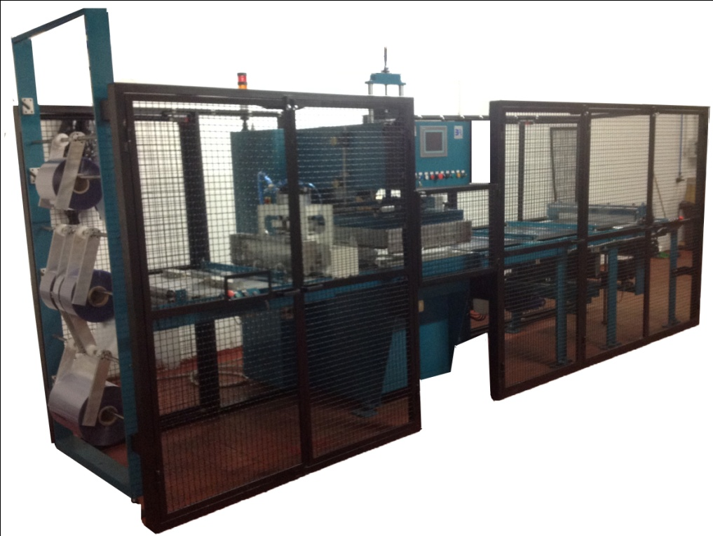
Specialized versions of the roll fed linear machine can far more complex. For example, a machine to produce the stationary binders can perform the following operations:
- Feed the upper and lower workpiece materials from rolls, automatically adjusting the roll tension.
- Place the grey board between two workpiece layers.
- Place the transparent PVC cover on the top of assembled worpieces
- Weld the assembled component.
- Place a pocket on the spine of the binder, then it to the spine.
- Strip the welding binder from the surplus material.
- Stack the striped binders onto conveyor belt
This type of automated machine is expensive and setting is up for a production run takes typically one to two hours. Therefore for economic operation, the machine would only be used for production batches of 1000 or more binders.
3.3.2 Rotary table
This type of machine incorporates a circular table, with number of work station. Operators can either assemble or strip a work piece at each work station. When a piece has been assembled, the whole table is rotated and the work piece is welded. After welding the table is again rotated and wokpiece stripped.
3.3.3 Shuttle Operated

The lover platen comprises two linked shuttle trays. Work pieces are prepared for welding in the shuttle trays. One tray is then moved under the welding head and weld is performed. After welding, the shuttle tray is moved away from the welding head and other tray is moved under the welding head. This type of machine enables two operators to prepare and finish products using only one welding head.
Another version of this type of machine is the up and over shuttle where two trays are arranged one above the other. This allows an operator to prepare and finish products on one tray while the other is under the welding head.
With auto tuning fitted to allow independent loading for each tray and with electrodes mounted in the trays, a different product can be made in each tray in alternate cycles.

TOOLING
Tooling is the part of machine is which is pressed onto workpeaces to perform the the weld. A typical simple tooling assembly is shown below. The tooling is issualy attached to a machine’s upper platen. However, if the construction of workpieces requires it, the tooling can be attached to the lower platen or in the tray.
Tooling Assembly
The tooling assembly comprises a tool plate on which is mounted a shaped strip of welding rule supported by lengths of aluminium fixing bracket. The area enclosed by welding rules is filled with packing.
The tool plate is made from sheet aluminium, which must be rigid enough to withstain the pressure applied during the welding process without distorting. For small tooling assemblies, as shown above, 3mm plate is commonly used. The tool plate incorporates a number of fixing holes to enable it to be bolted to the platen.
Welding Rule
The welding rule is made from brass strip and is available in a wide range of profiles to enable a variety of welds to be performed. There are two main classes of welding rule as shown.
- Plain seam

